(DHANKAWADI, PUNE-43)



MINI PROJECT REPORT ON

“Mall Management Systems”

SUBMITTED BY

Aditya Kabra (3942)

Junaid Magdum (3947)

Motish Mehta (3949)

Pranav Agrawal (3960)

(Third Year Information Technology)

UNDER THE GUIDANCE OF

Prof. R. B. Murumkar

Submitted To

**Pune Institute of Computer Technology**

**For Academic Year 2017-18**

|  |  |
| --- | --- |
| **TITLE** | **PAGENO** |
| **1. Introduction** | **3** |
| **2. Scope and Limitations** | **4** |
| **3. Flow Diagram** | **5** |
| **4. E-R Diagram (description)** | **6** |
| **5. Normalization (up to 3NF)** | **7** |
| **5. Coding - Procedure and Triggers, View Design (Description)** | **8** |
| **5. Coding Design (Form Snapshot)** | **9** |
| **6. User Interface Snapshots** | **13** |
| **7. Conclusion** | **29** |

# INTRODUCTION:

**1.1 - PURPOSE:**

Admin Interface and Functionalities for a Mall Management System along with a Customer Portal for Customers to view the Products .

# 1.2 - SCOPE:

1. The software can be used in Malls for managing all activities in a mall from an administrator point of view.
2. Software is made for centralized information maintenance of Malls and all the employees and stores within.
3. Central administrator has the control on all the activities, w.r.t. adding, deleting, modifying database information and accessing the daily sales in the Mall.
4. Each Employee has their own login. The Administrator, Manager and Employees will be guided to different functionalities based on their individual logins.
5. Administrator is at the top of the privilege chain followed by 2 Managers for each of our departments – Clothing and Food. Each department consists of various stores and a Store Manager manages proceedings of his/her store. The last employee in the privilege chain is the Sales Clerk for handling products in the store.
6. Each new order has the functionality of accepting the Customer details, along with details of the products and the details of the store to which the product belongs.
7. A Customer is entitled to discounts on the total price of his product based on current offers. A final price for each product is generated from the database which is calculated based on the discount and quantity of products purchased.
8. An Invoice is generated in pdf format for each order highlighting all the important details of the order such as the employee who has billed the order, the details of the products purchased and the customer contact details along with a unique invoice number.
9. Our Database stores details of all the employees that includes their Personal Details and Contact Numbers, Job Information and Emergency Contact Details in case of any medical emergency.
10. Searching and Sorting functionalities based on the Employee Id and Employee Name have also been included to simplify data access for the administrator and managers.
11. A Customer Portal is available for potential Customers to view our products online. Customers have access to products of every clothing and food store. Customers can see Images and Prices of these products beforehand for them to decide which products to buy.

# – DEFINITIONS , ABBREVIATIONS AND ACRONYMS :

* SQL – Structured Query Language

# – REFERENCES :

* [www.google.com](http://www.google.com)
* [www.stackoverflow.com](http://www.stackoverflow.com)
* [www.w3schools.com](http://www.w3schools.com)
* www.mysqltutorial.org

# – DEVELOPER’S RESPONSIBILITIES :

1. Developer must provide simple and clean interface for user
2. Developer must follow all regulations and guidelines for development of the project .
3. Technologies used by the developer must be latest and flexible .
4. Developer must constantly build on this product .
5. He/She must follow customer requirements and fulfill them .
6. Developer must complete project and update requirements in less time
7. Developer must look for customer feedback and suggestion and must make changes accordingly
8. Developer must see to it that the product he has build is usable on various different platforms
9. Developer must abstract key features and must provide implementation for user

# GENERAL DESCRIPTION

## **2.1 – PRODUCT FUNCTION PERSPECTIVE** :

1. Our product looks to provide an administrator interface for managing a mall
2. Product function perspectives include simple usability for management activities
3. Creation , Updation and Deletion facilities
4. Overall Summary analysis

# 2.2 – USER CHARACTERISTICS :

* Users tend to show easy understanding of functionalities
* Some users are interested in additional functionalities
* Users tend to show knowledge of order management system

# 2.4 – GENERAL CONSTRAINTS :

1. Application is not hosted and hence does not have Online Support
2. Searching facility is absent in the Customer Portal.
3. Maintaining the central sales record is less secure.

# 2.5 – ASSUMPTIONS AND DEPENDENCIES :

1. Basic Understanding of Order Management System from User Side
2. Internet Connection for smooth flow
3. Latest and Updated Files for complete project

# SPECIFIC REQUIREMENTS

# 3.1 – INPUTS AND OUTPUTS :

1. Input Case for Employee Form – Employee Personal Information , Job Information which includes Title , Supervisor and Employee ID , Emergency Contact Details
2. Output Case for Employee Form – Submission of all input data into tables and retrieval of data from database . Searching and Sorting of data of employee based on ID , date etc.
3. Input Case for Sale Form – Customer Information , Employee Information as to who is making the sale , Products along with the Name , Quantity , Discount and Total Price Details of the Sale
4. Output Case for Sale Form – Submission of all input data into tables and retrieval of data from database . Searching and Sorting of data of employee based on ID , date etc . PDF generation of Invoice of Purchase

# – PERFORMANCE CONSTRAINTS :

* Beginner will find it hard to manage the activities
* Checking and verification of sale involving large amounts of products is not validated
* No provision for tax included in any sale

# 3.6 – ACCEPTANCE CRITERIA :

* All input cases that have proper validations
* All input requirements marked with an asterisk
* Valid entries for discount , customer information

The main modules in this Project are as follows:

* Customers
* Employees
* Job Title and Privileges
* Stores
* Products
* Orders
* Customer Portal

# SYSTEM DESIGN

# 4.1 - E-R Design :

# 

# 4.2 - SCHEMA DESCRIPTION :

# 4.3 – TABLE DESCRIPTION :

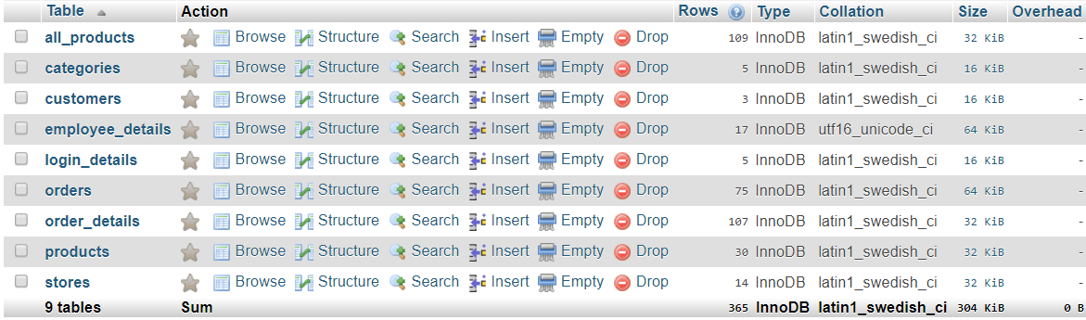

# 

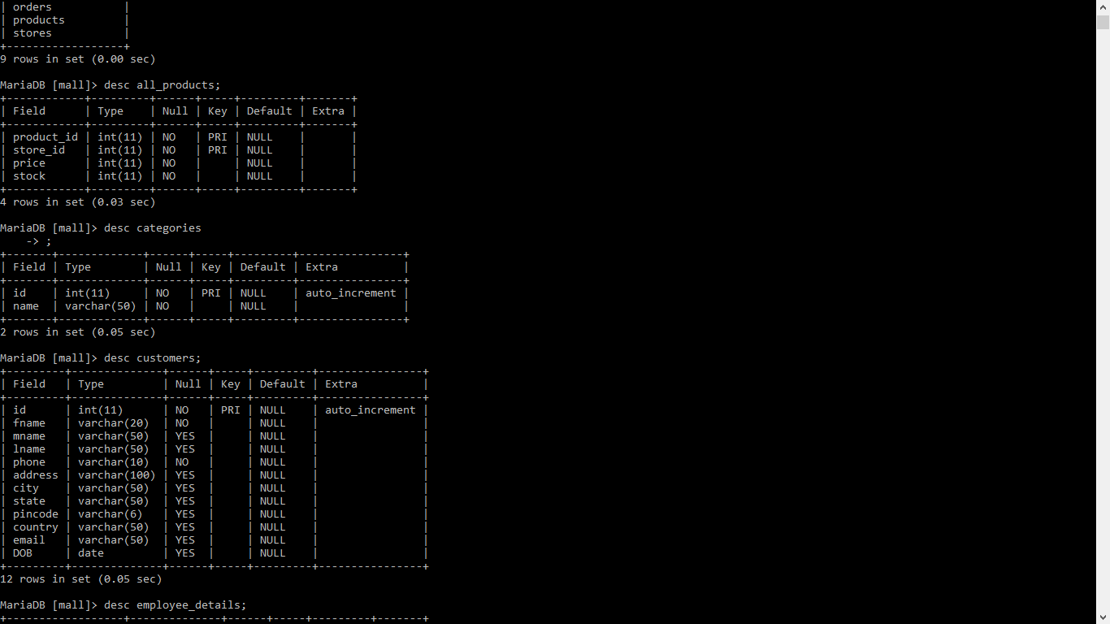

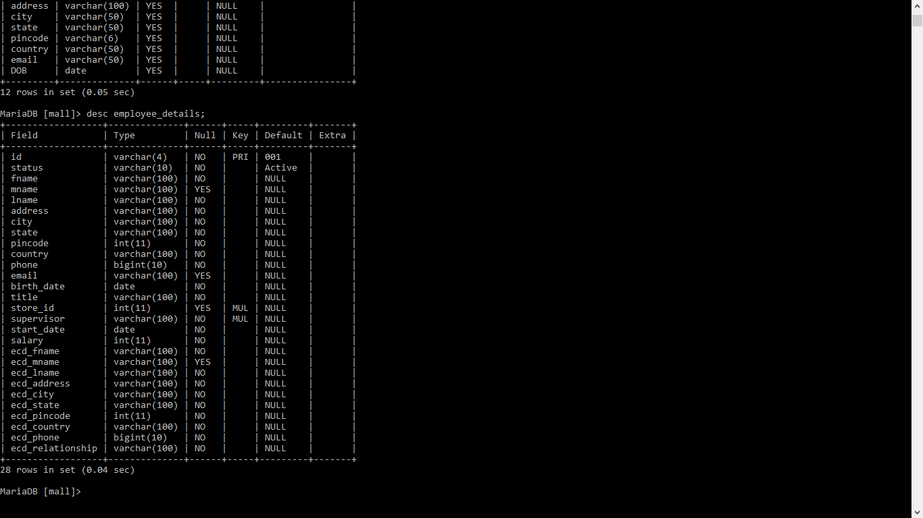

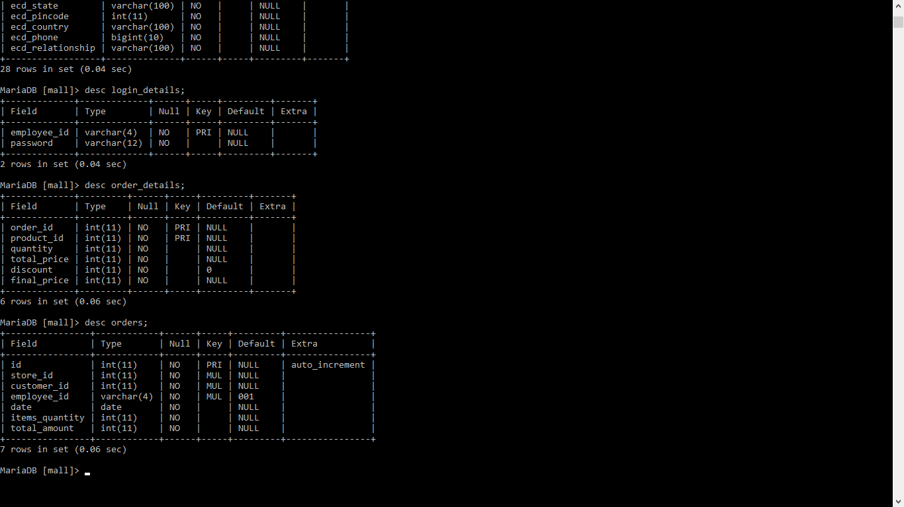

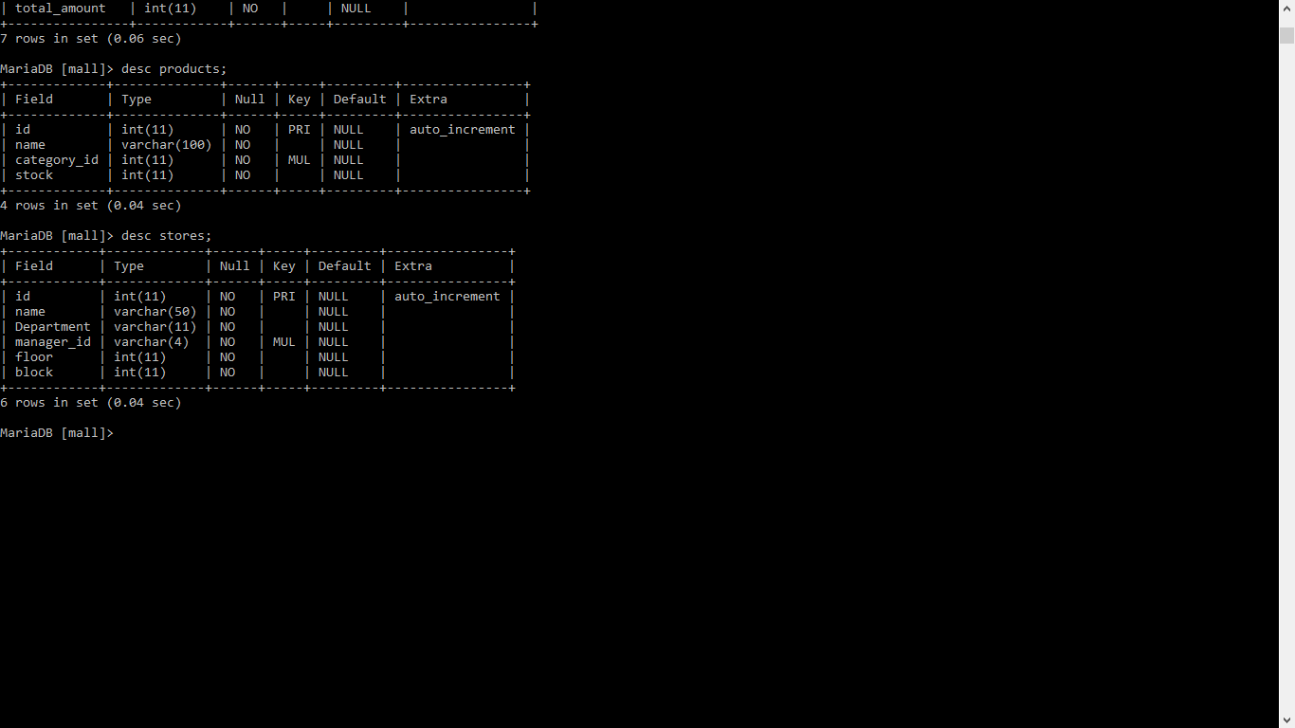

# CODING :

# Procedures Used:

**1. Procedure for generating unique Employee ID for each Employee:**

CREATE PROCEDURE `generate_id`(IN `dept` VARCHAR(20), OUT `genid` INT)

BEGIN

SELECT COUNT(store_id) INTO genid

FROM employee_details

JOIN

(SELECT id FROM stores WHERE department = dept)st

ON employee_details.store_id=st.id;

END

**2. Procedure for getting Full Name of Manager via store name:**

CREATE PROCEDURE `get_manager`(IN `strname` VARCHAR(20), OUT `fullname` VARCHAR(50))

BEGIN

SELECT concat(fname,' ',mname,' ',lname)

INTO fullname

FROM employee_details

WHERE id = (SELECT manager_id FROM stores WHERE name=strname);

END

# Triggers Used:

**1. Trigger for updating stock in products table if a product is added in a particular store:**

CREATE TRIGGER `product_stock_on_insert`

BEFORE INSERT ON `all_products`

FOR EACH ROW

BEGIN

update products

set stock = stock + new.stock

WHERE new.product_id = id;

END

**2. Trigger for updating stock in products table if a product’s stock is updated in a particular store:**

CREATE TRIGGER `product_stock_on_update`

BEFORE UPDATE ON `all_products`

FOR EACH ROW

BEGIN

UPDATE products

set stock = stock - old.stock + new.stock

WHERE old.product_id = id;

END

**3. Trigger for updating stock in products table if a product’s stock is updated in a particular store:**

CREATE TRIGGER `Order_details_insert`

BEFORE INSERT ON `order_details`

FOR EACH ROW

BEGIN

SET new.total_price = new.quantity * ( SELECT price FROM all_products WHERE product_id = new.product_id AND store_id = ( SELECT store_id FROM orders WHERE id = new.order_id ) );

SET new.final_price = new.total_price * ( 1-new.discount / 100 );

UPDATE ordersSET items_quantity=items_quantity+new.quantity

WHERE id=new.order_id;

UPDATE orders

SET total_amount=total_amount+new.final_price

WHERE id=new.order_id;

UPDATE all_products

set stock=stock-new.quantity

where product_id=new.product_id and store_id=(select store_id from orders where id=new.order_id);

END

# 4.6 – ERROR MESSAGES / ALERTS DESIGN :

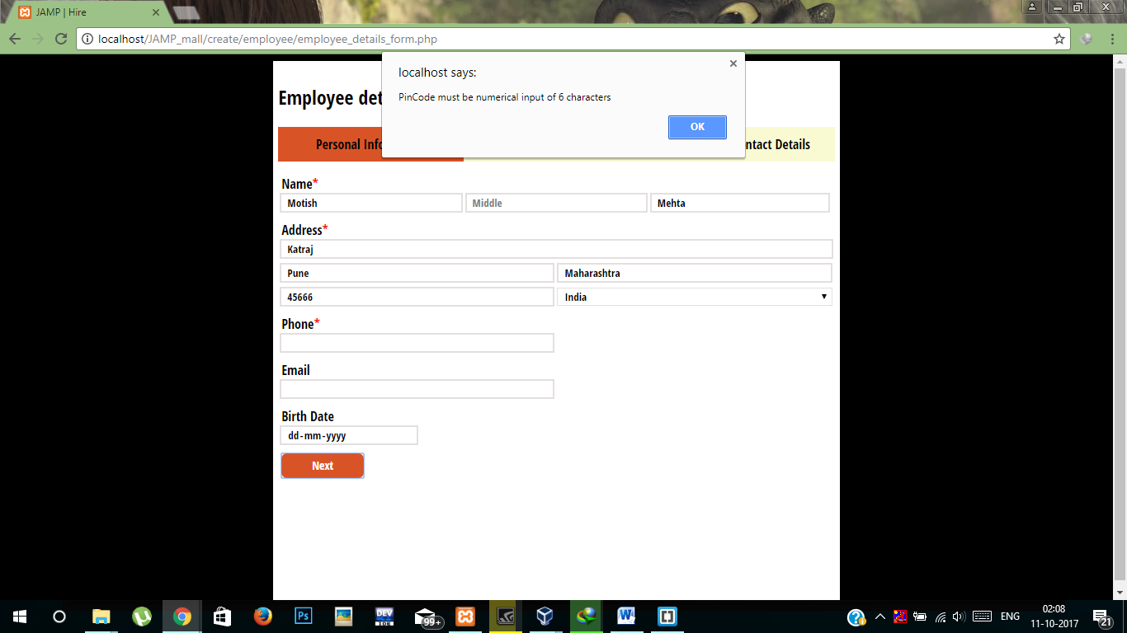

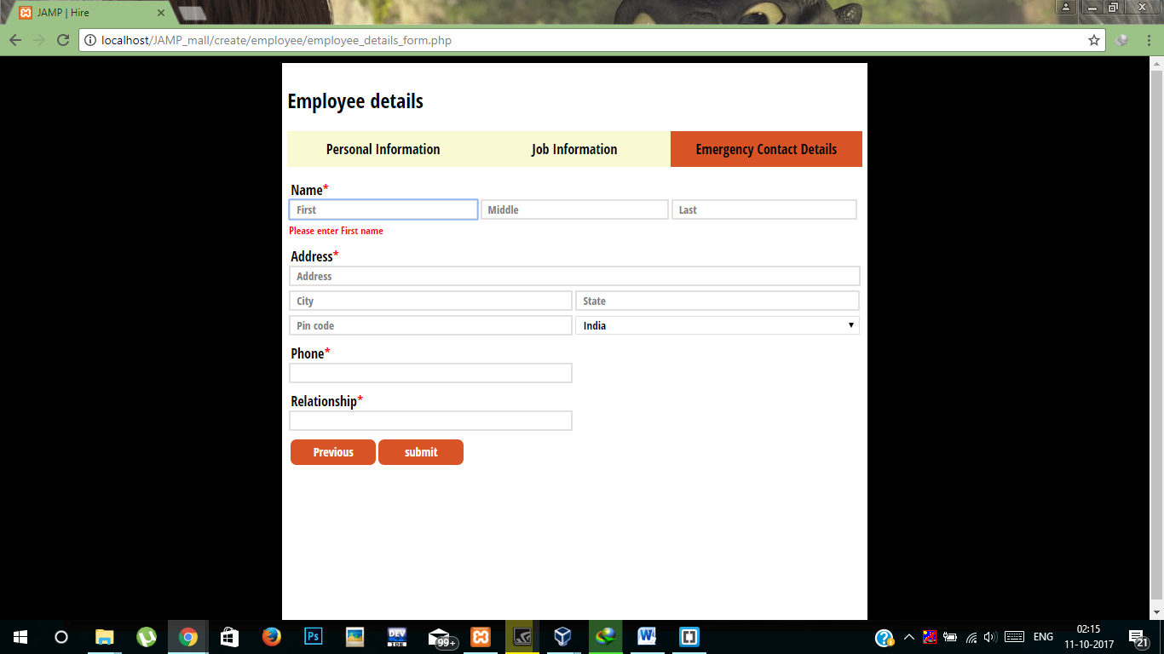

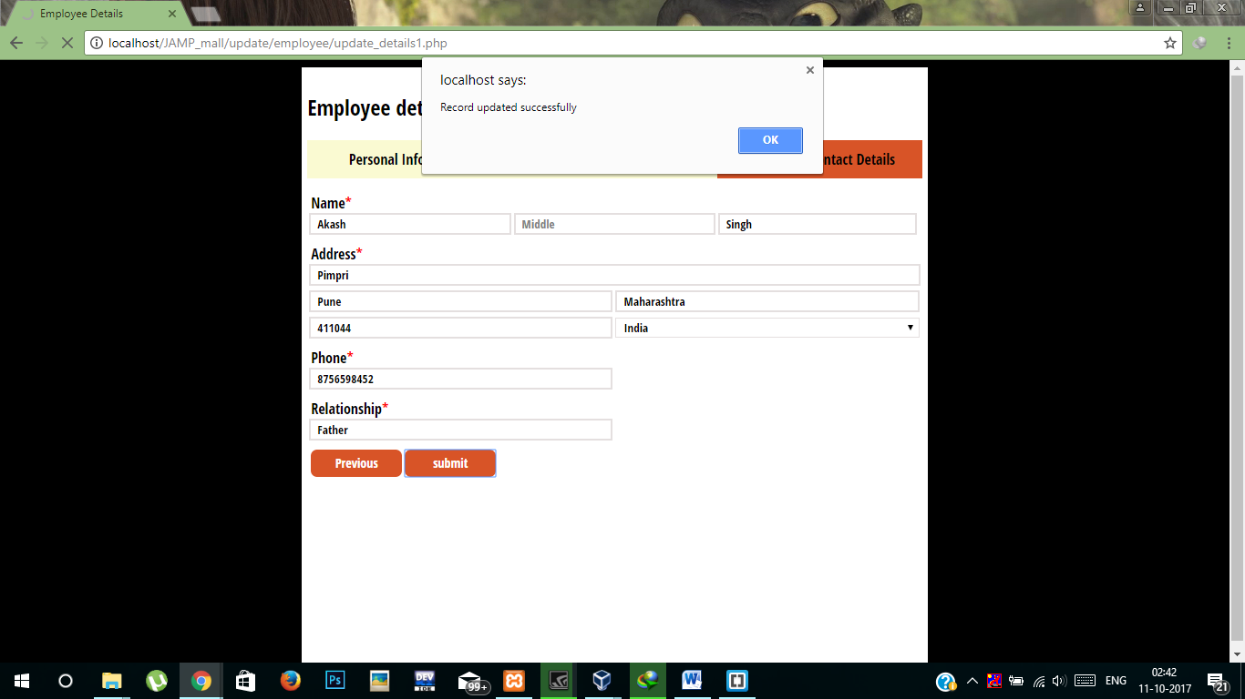

# 4.5 – USER INTERFACE DESIGN :

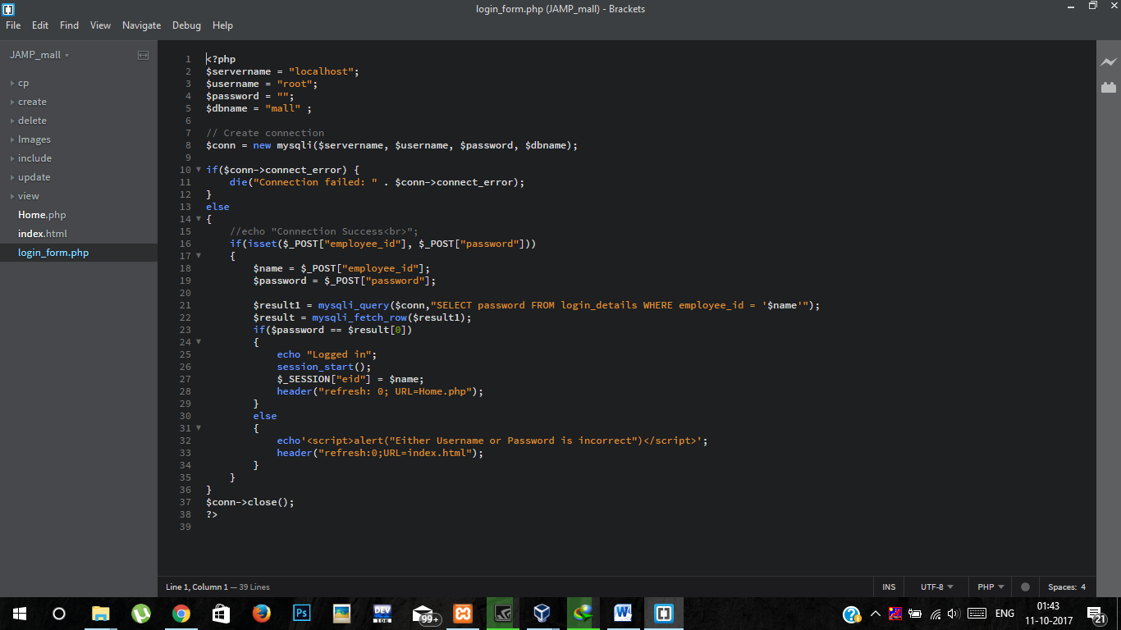

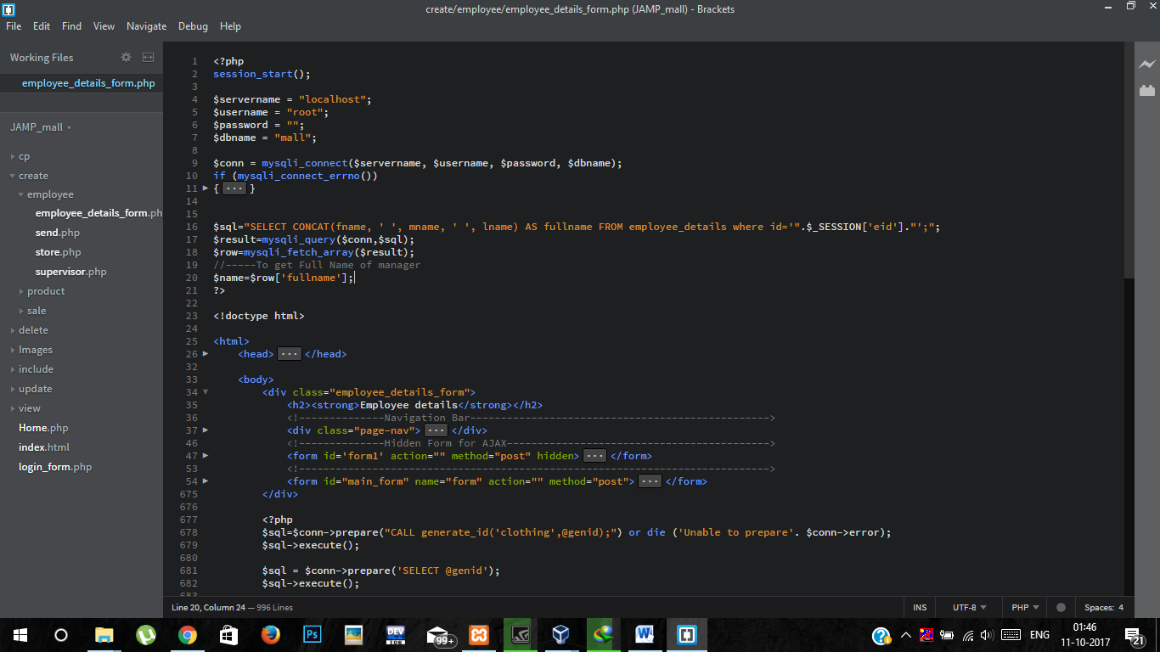

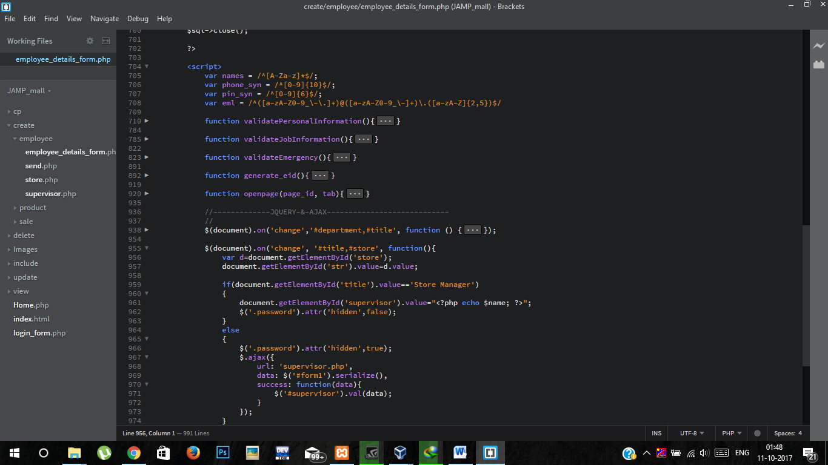

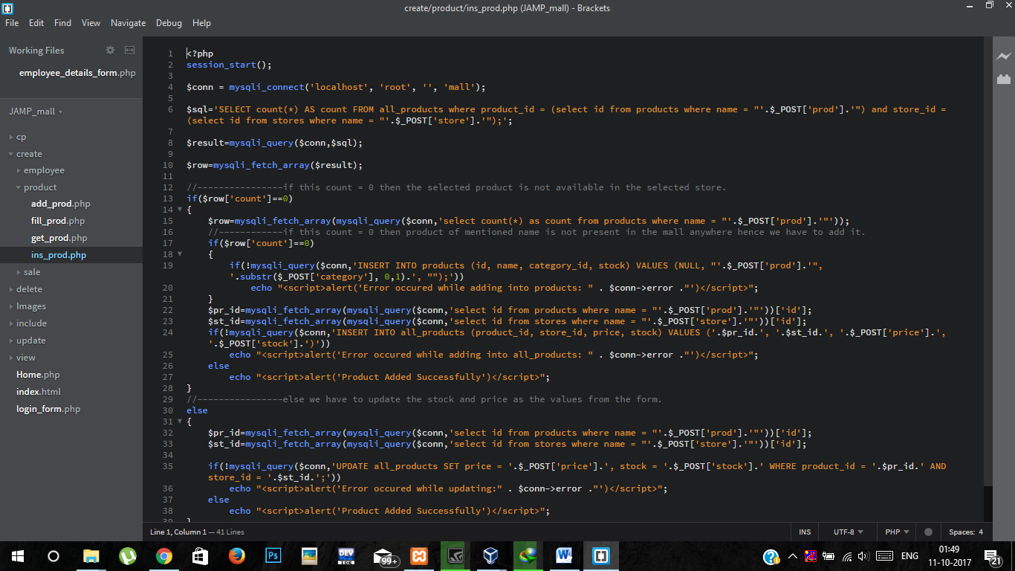

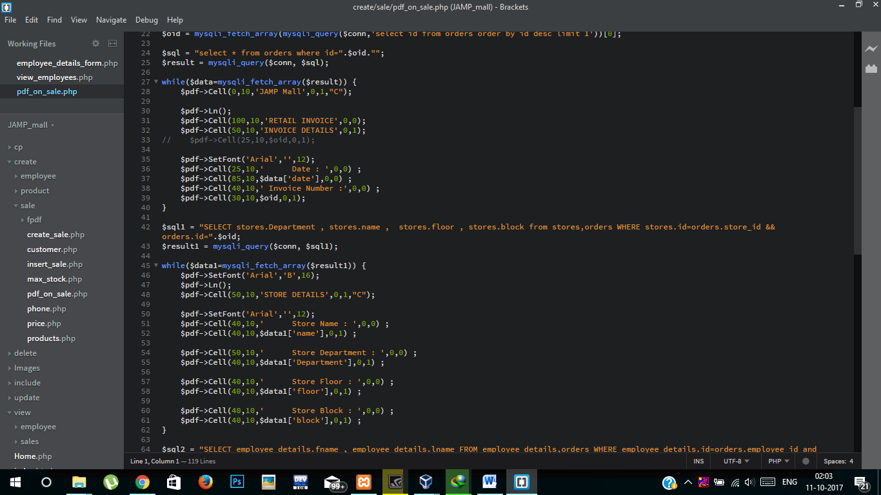

# User Interface Snapshots:

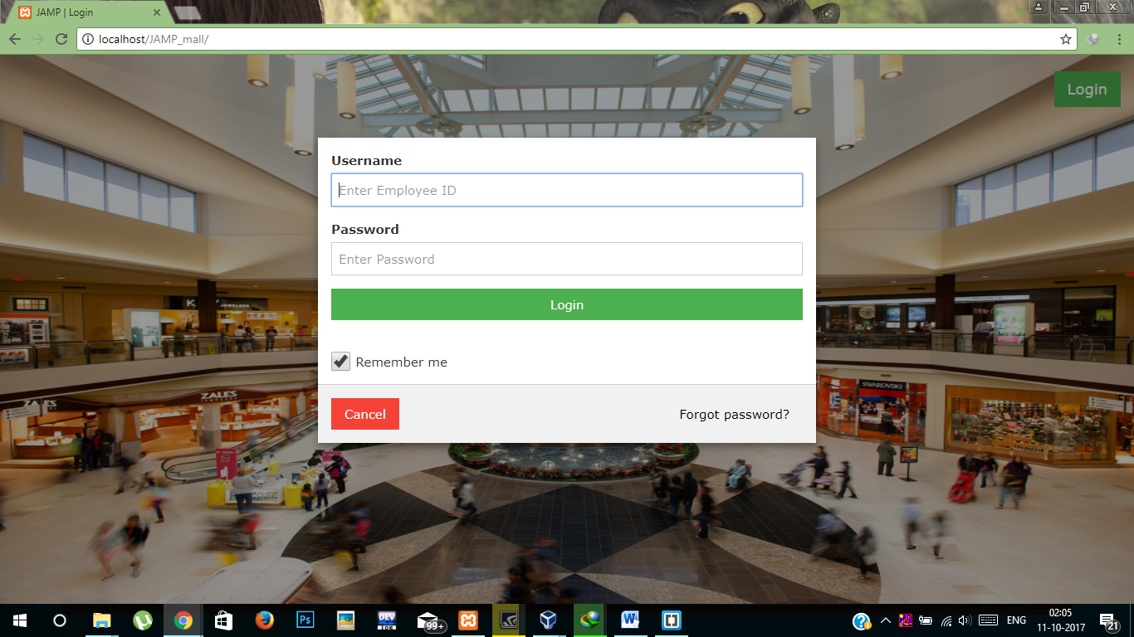

ADMIN Flow(Similar for department Manager):

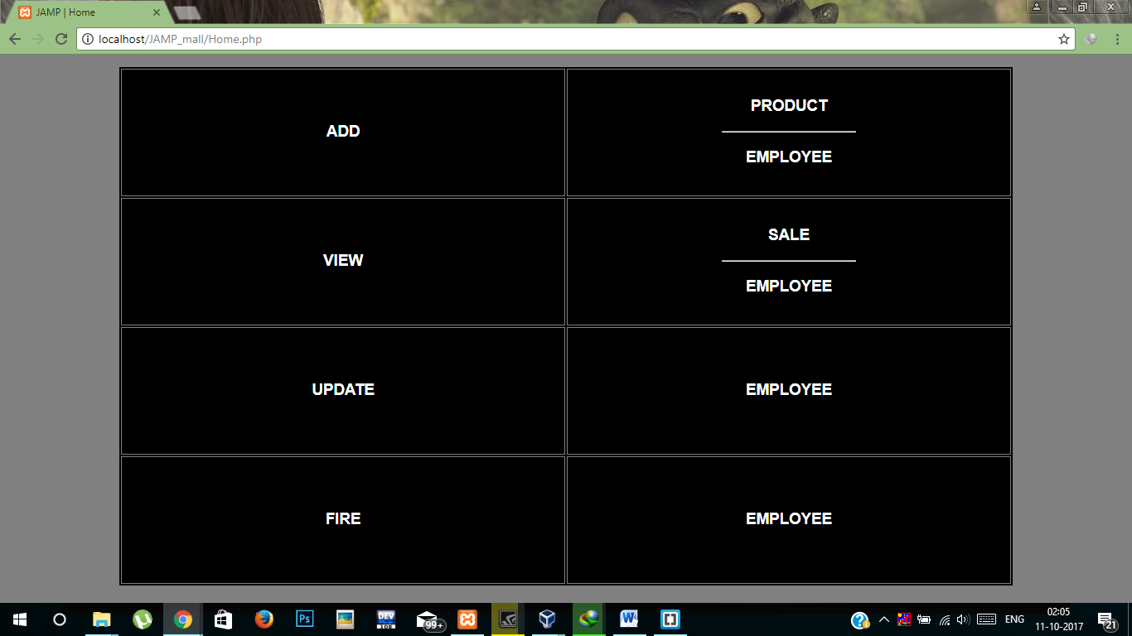

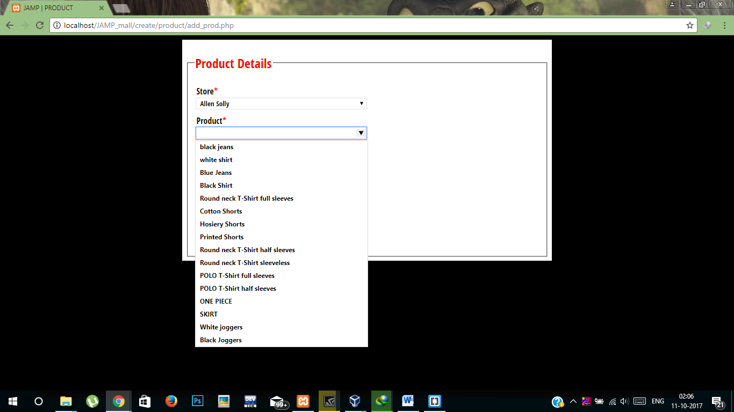

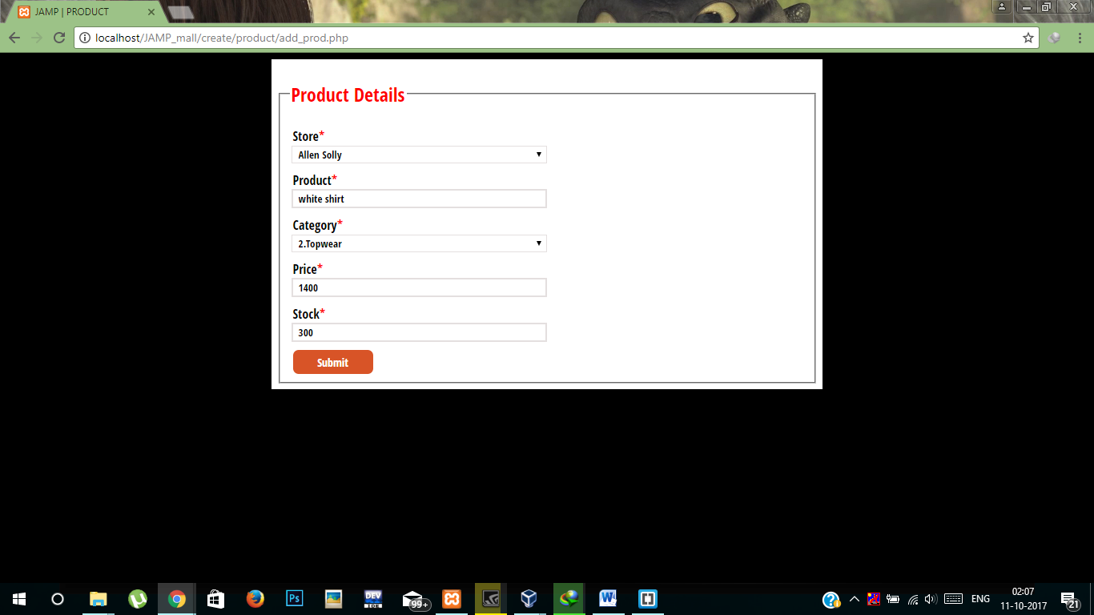

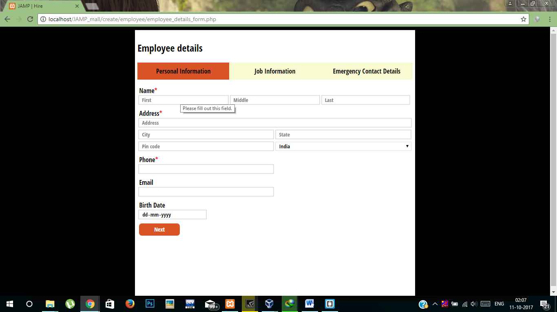



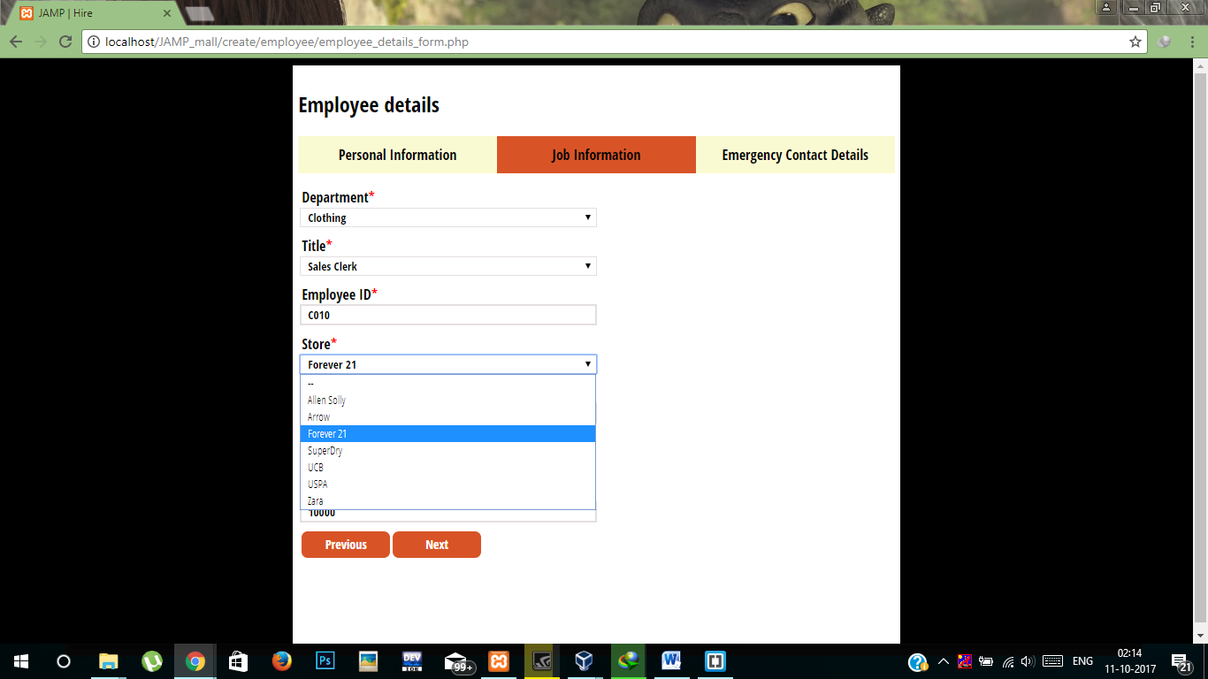

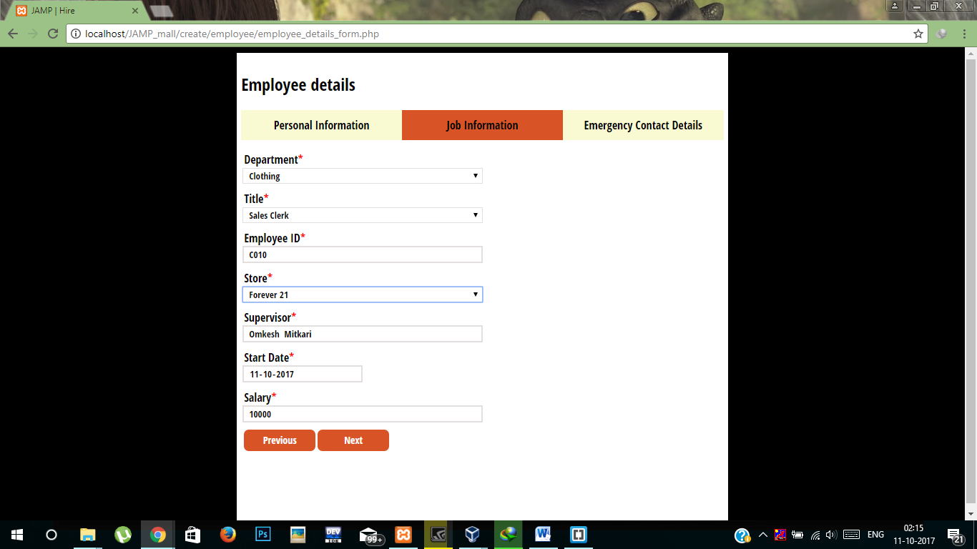



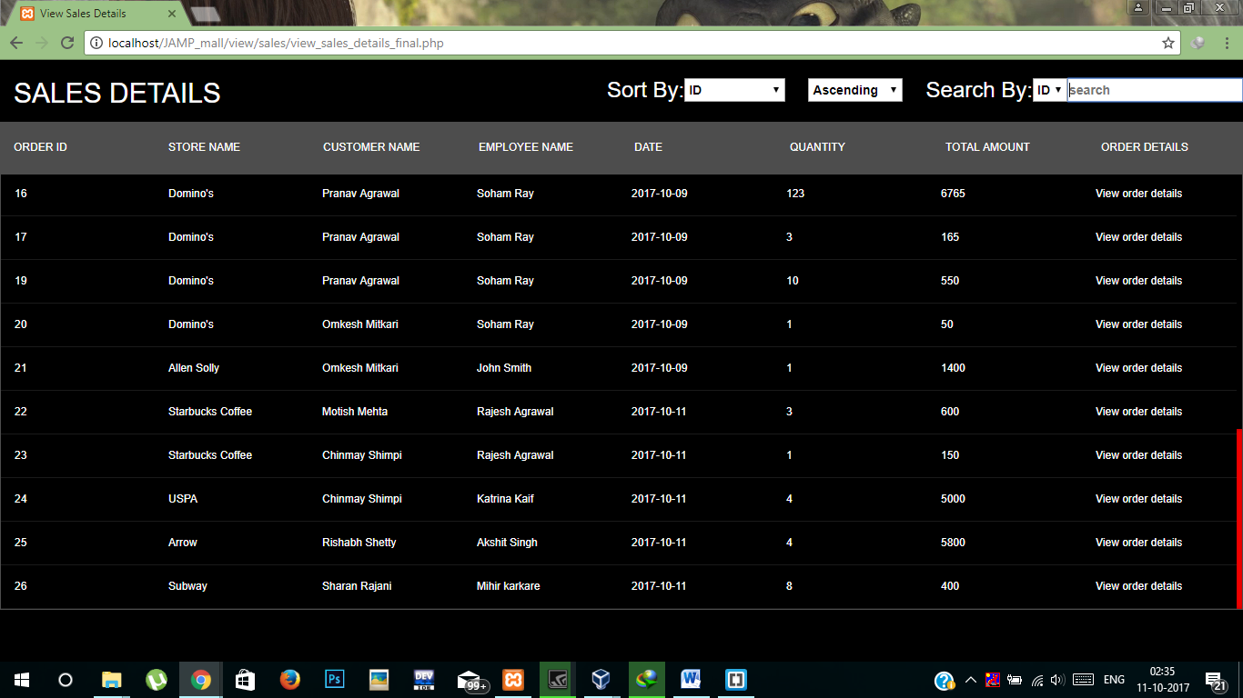

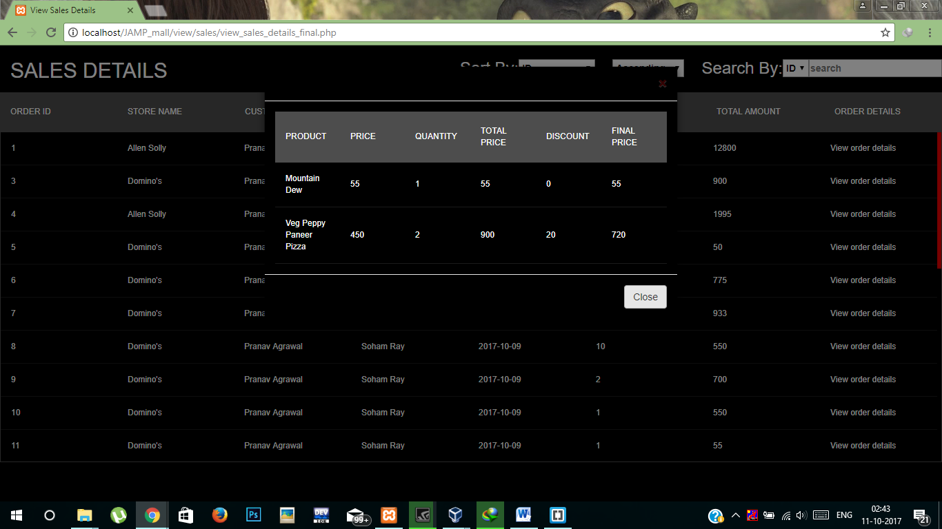

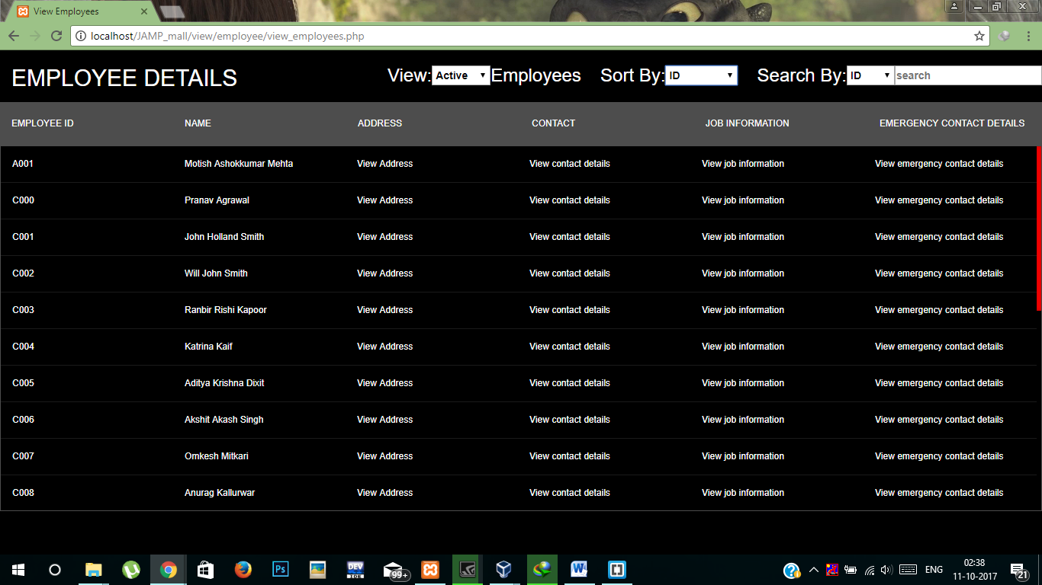

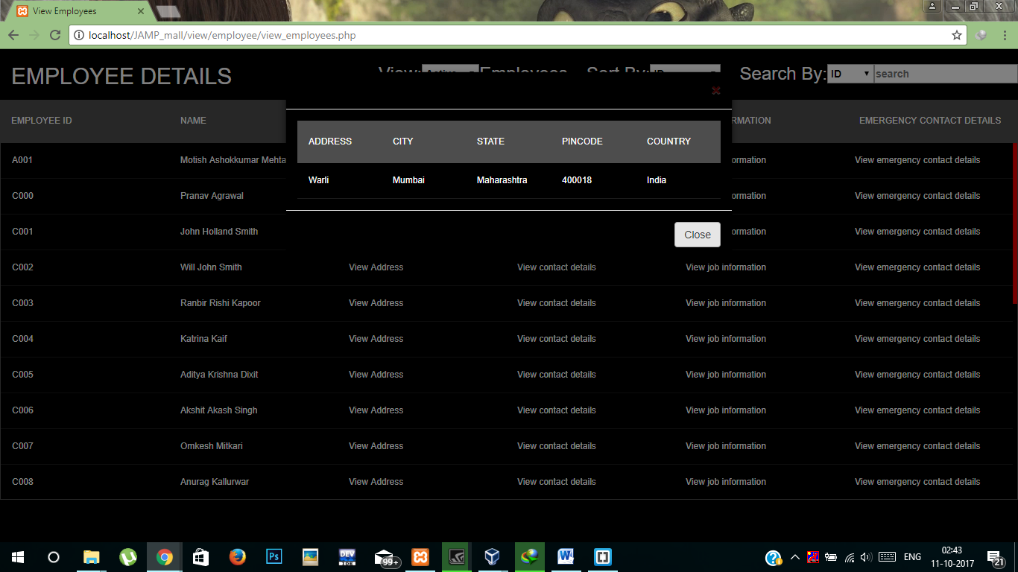

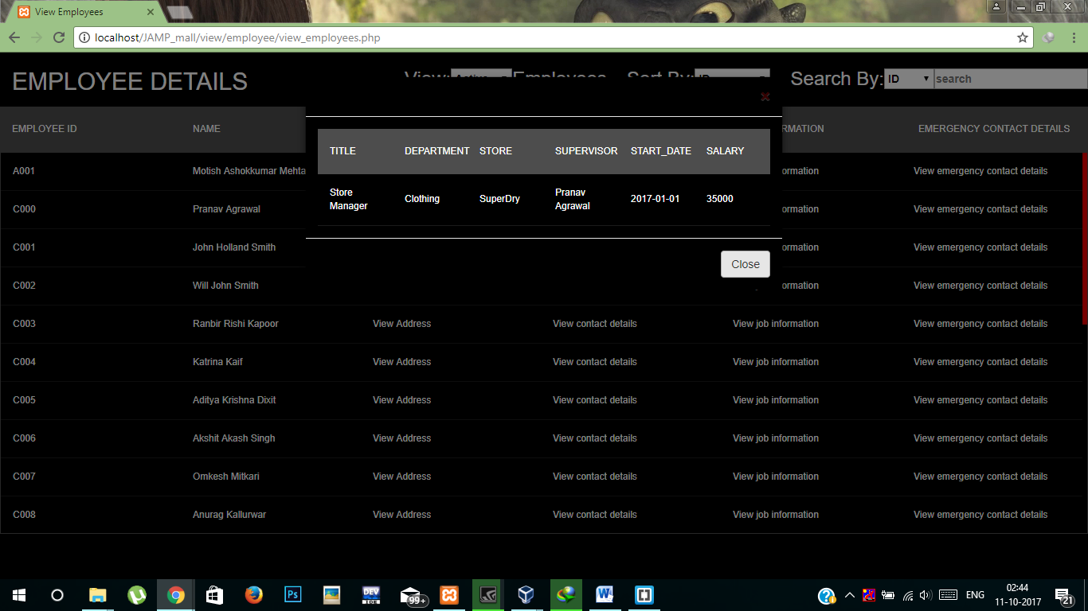

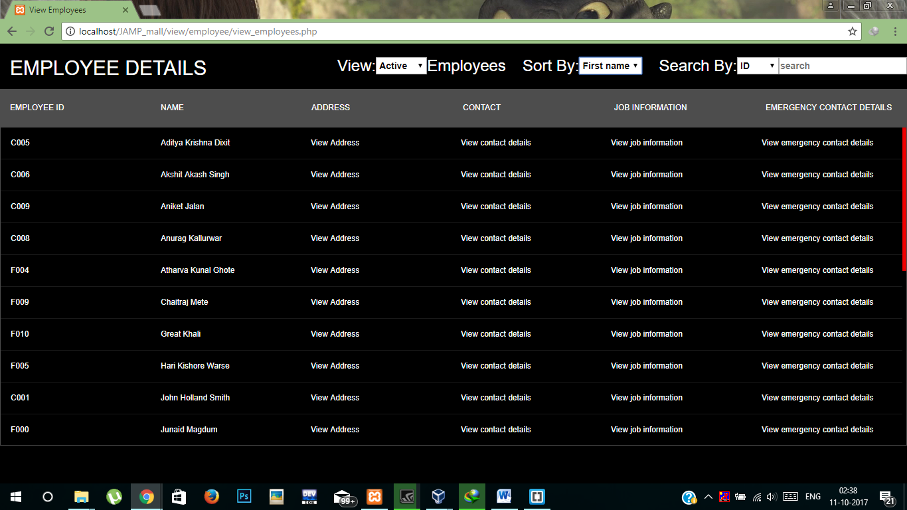

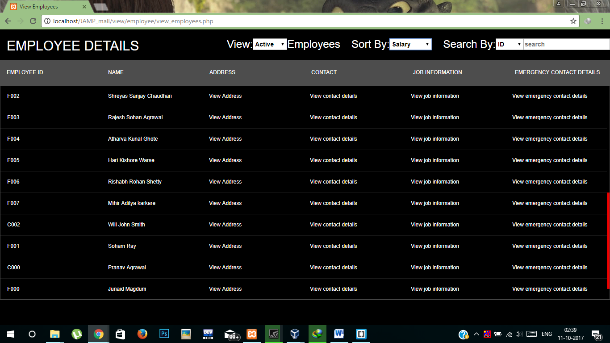

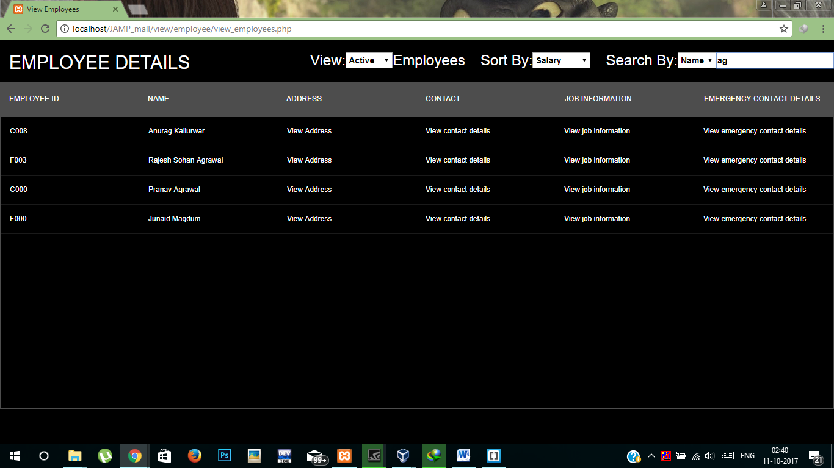

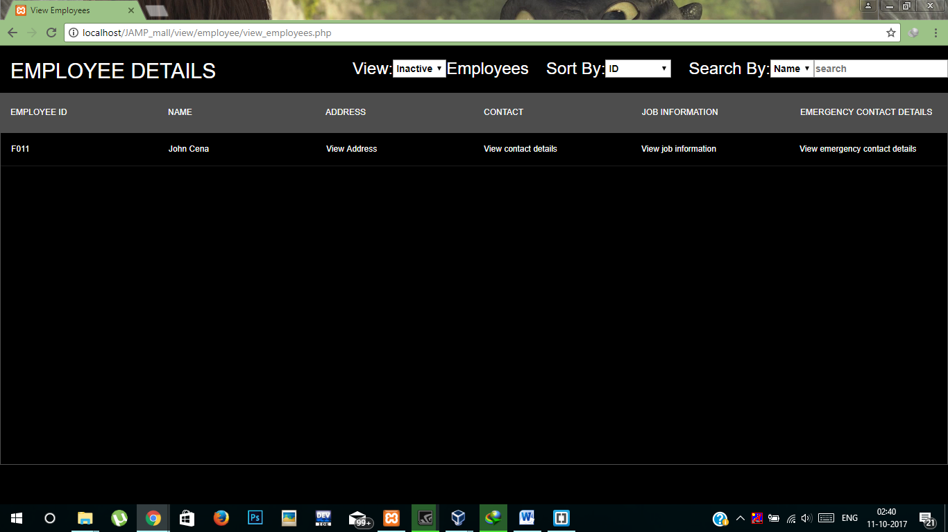

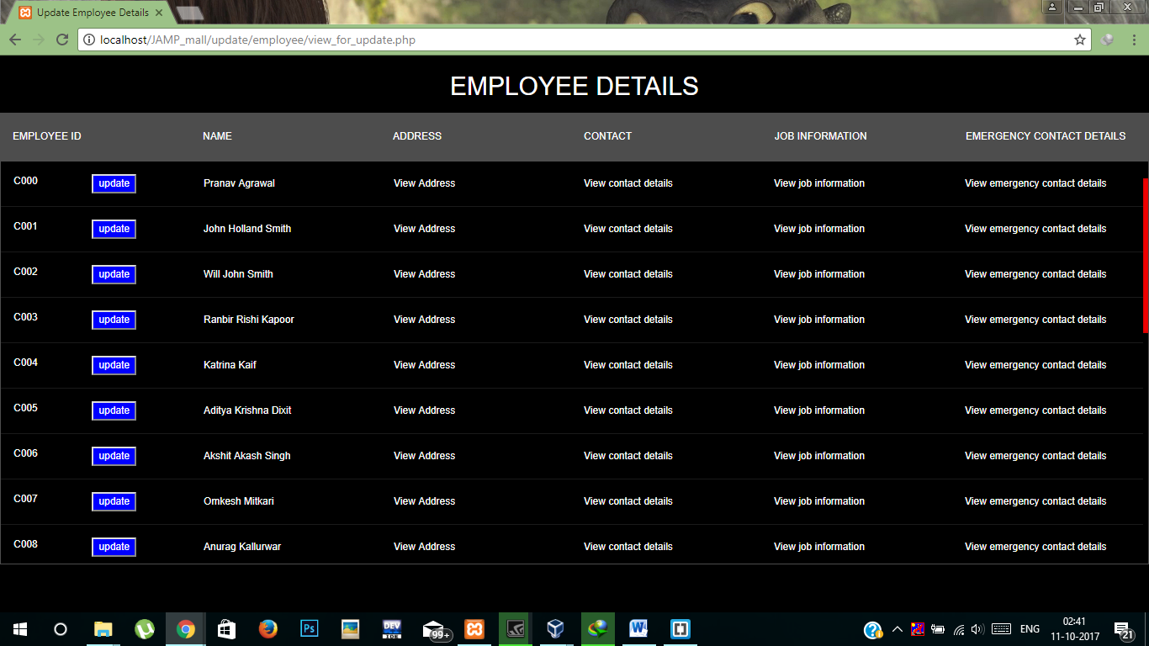

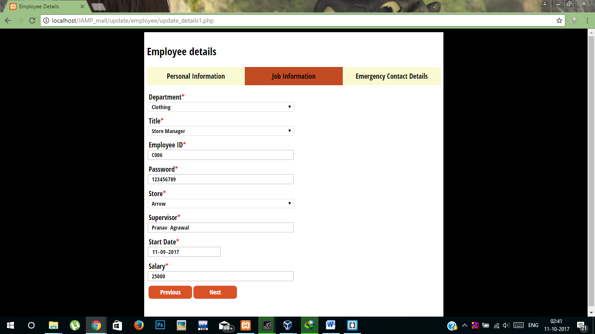



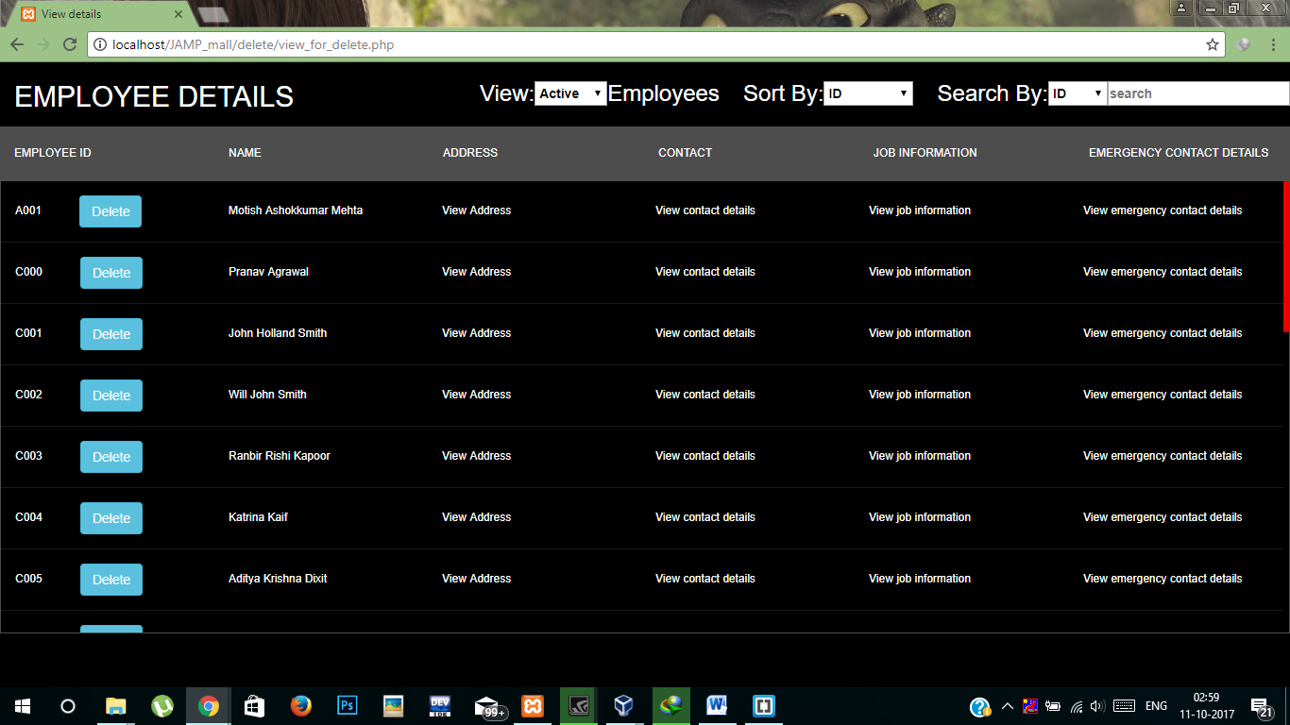

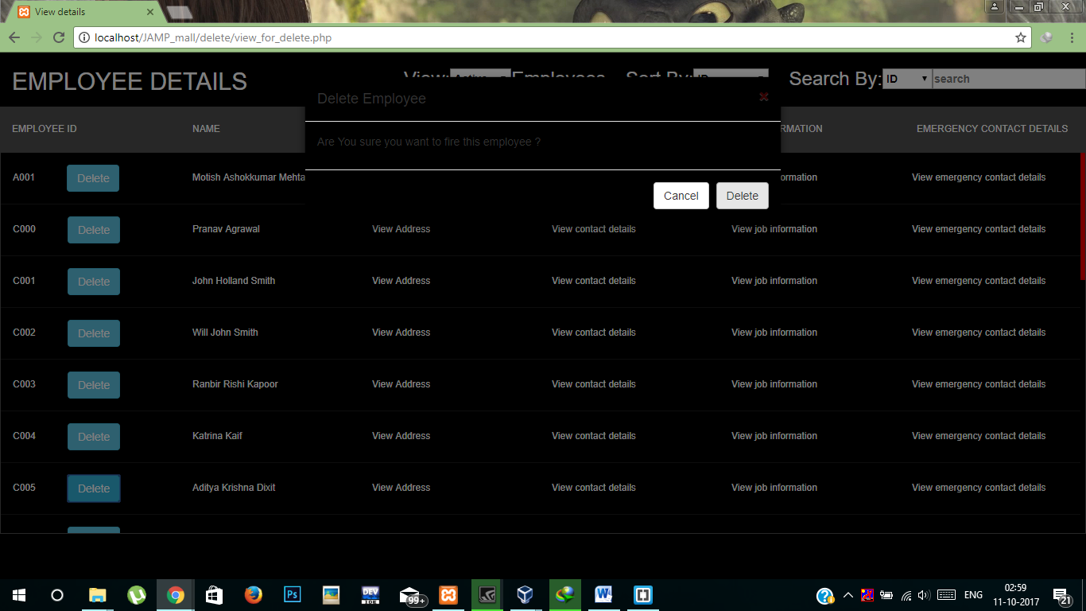

Store Manager Flow(Changed/Additional Pages):

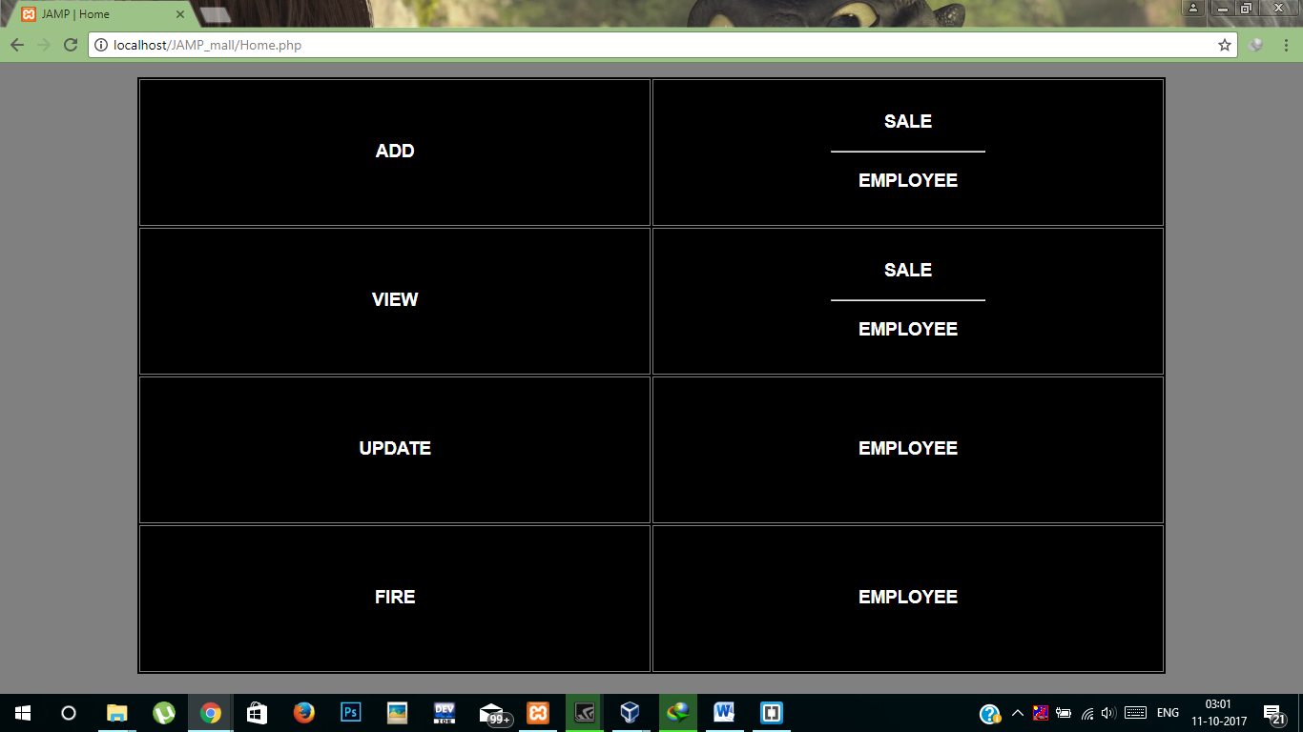

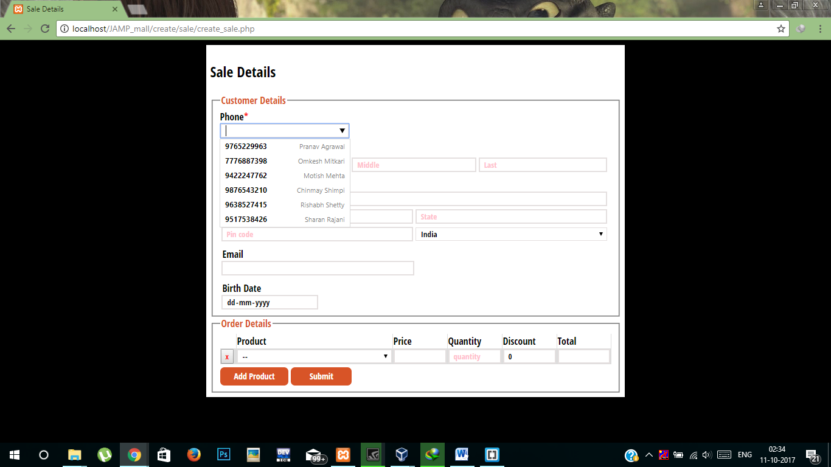

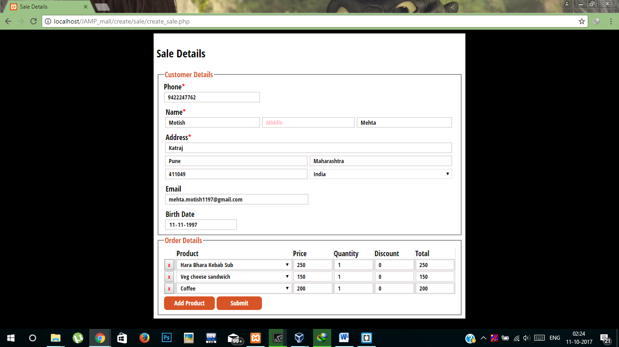

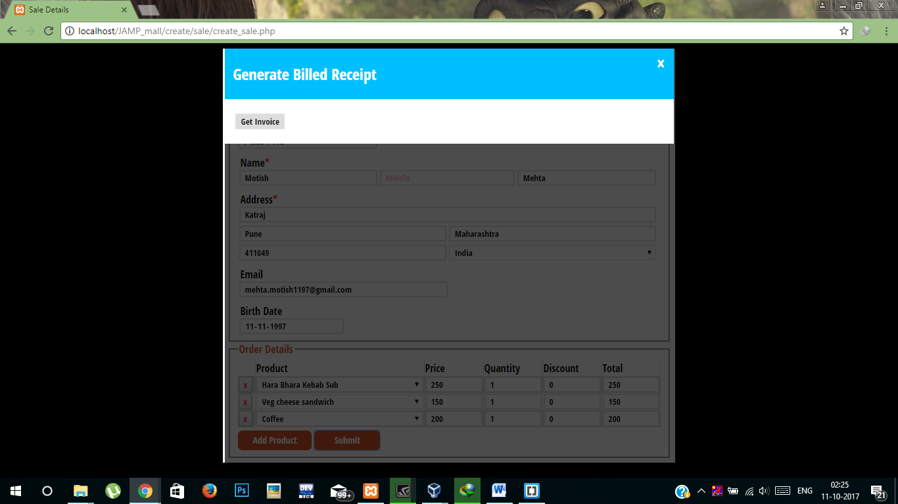

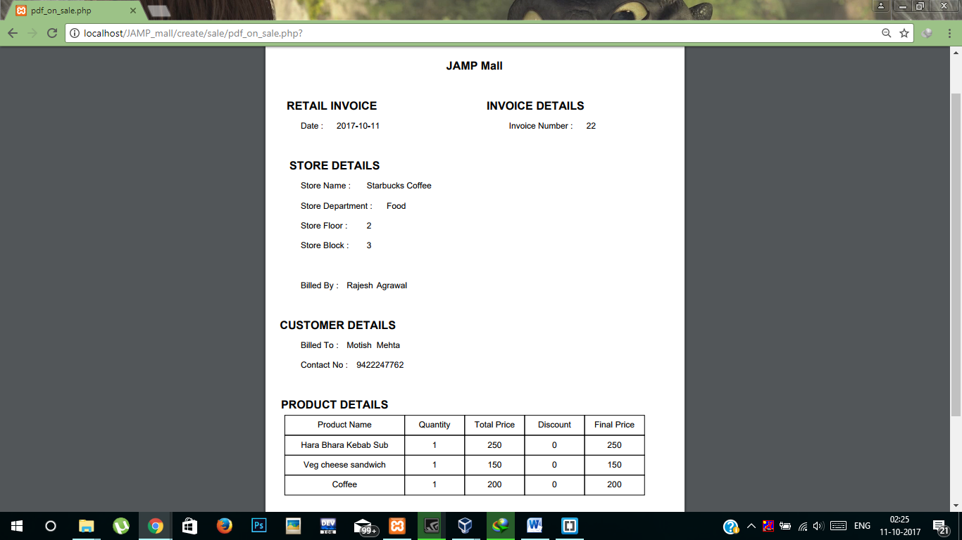

# 

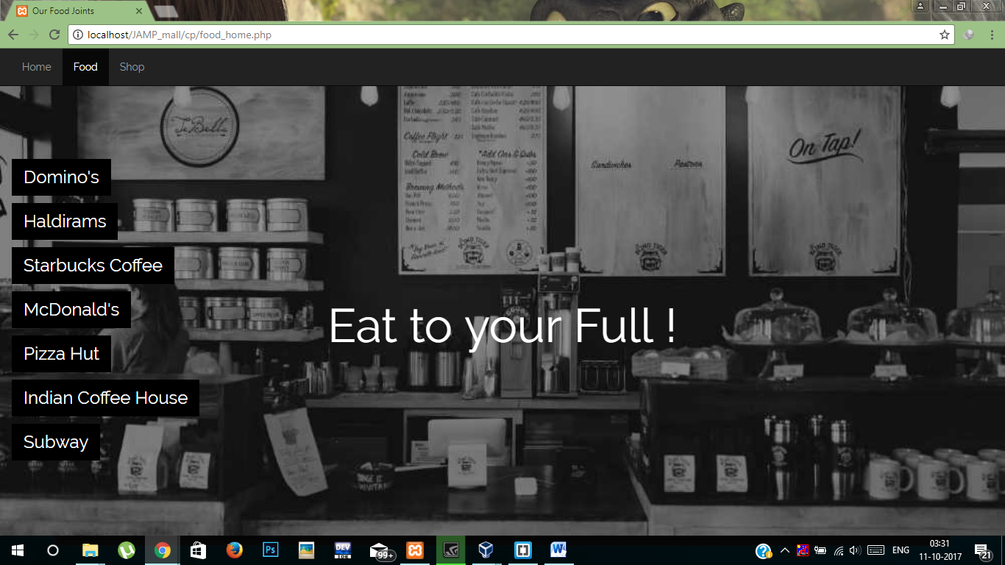

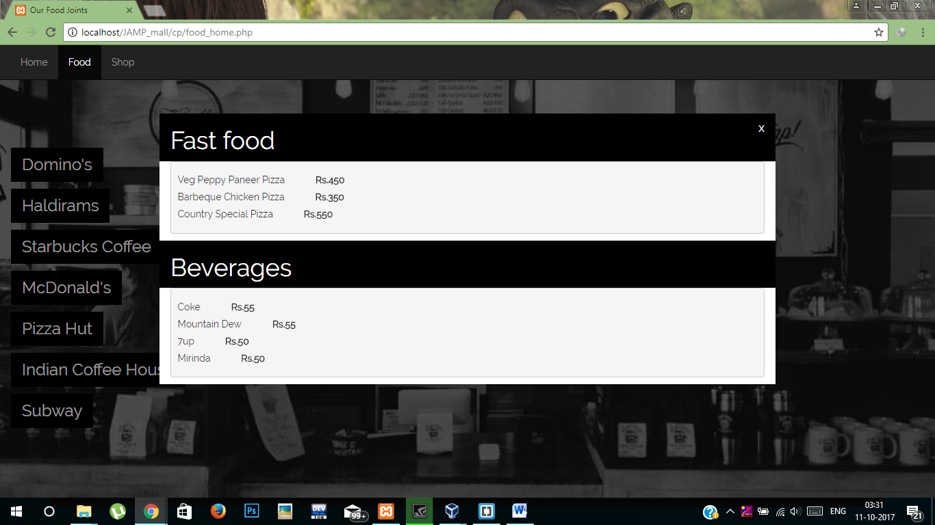

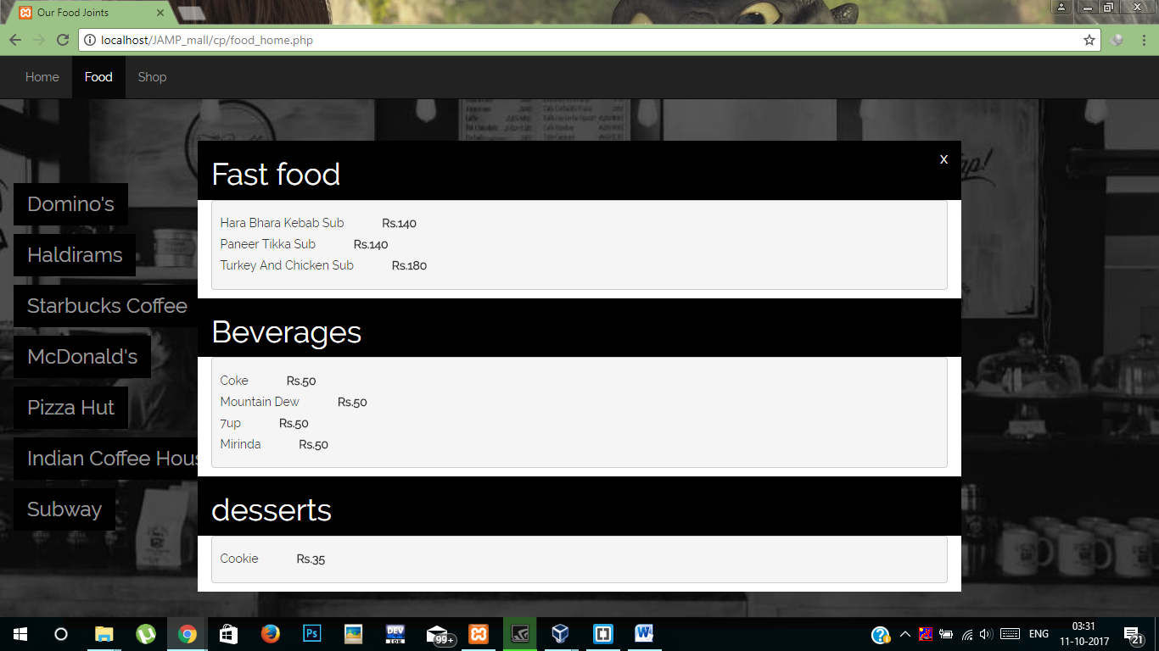

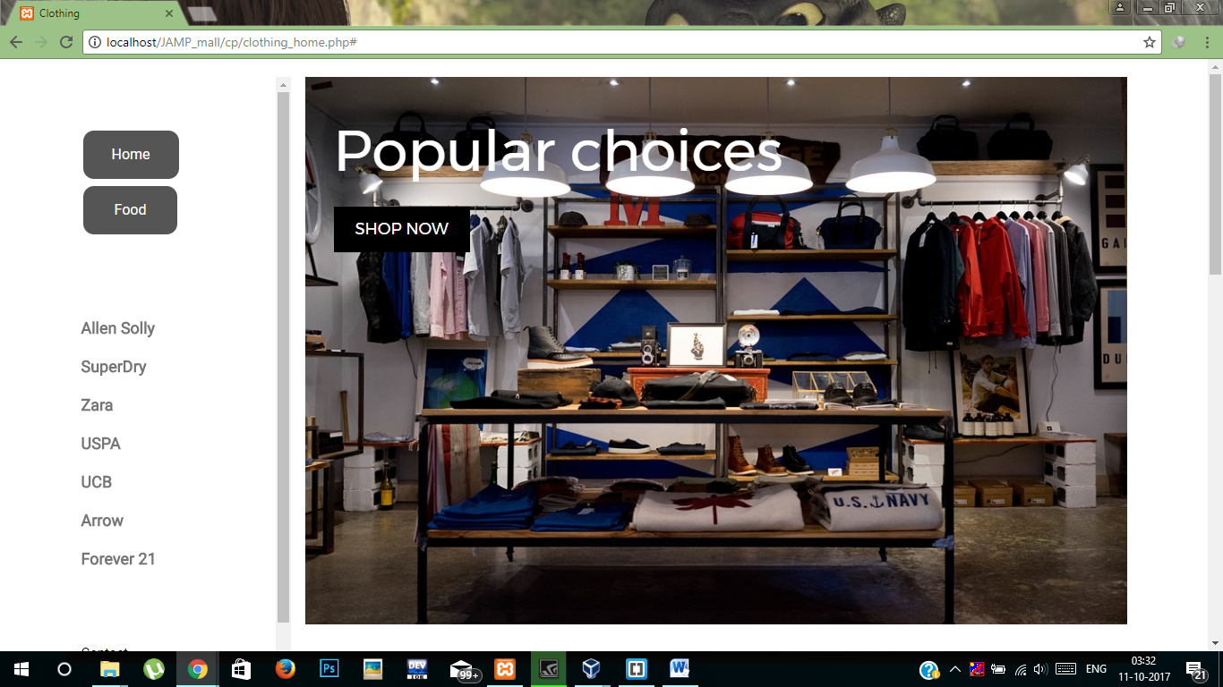

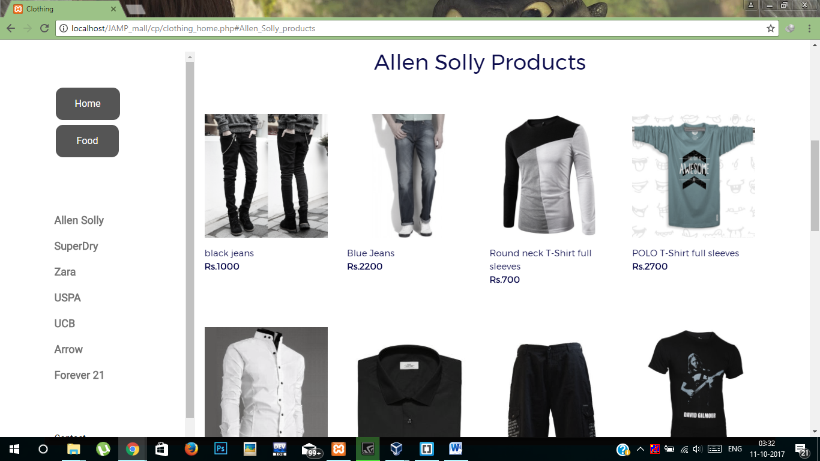

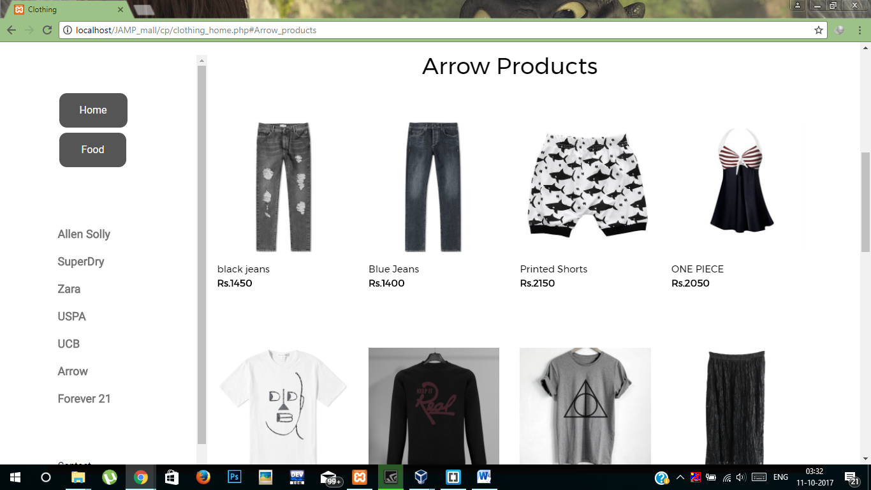

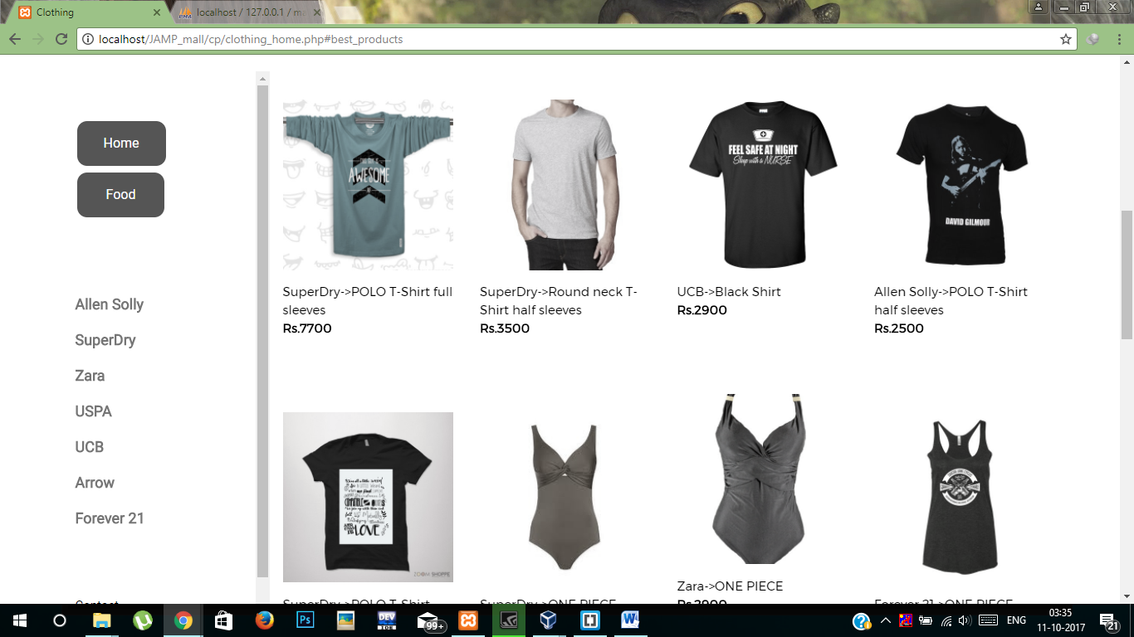

# ­5.1 – HARDWARE / SOFTWARE PLATFORM :

Intel core I3/I5 Processor, XAMPP, Google Chrome.

# 5.2 – TOOLS USED :

* Google Drive
* Brackets
* Sublime Text Editor
* XAMPP

# 5.4 – FUTURE WORK / EXTENSION

* Validation of Quantity and Stock for Sales
* Summary of a day’s sales
* GUI Improvement

# 5.5 - CONCLUSION

The three parts which are essential for this project are User interface, Creation of relational database and SQL engine.

The Project is entirely based on database management system concepts. The back-end use for project is MySql and front-end is PHP , HTML , CSS , JavaScript and AJAX . The Coding of Sql queries through PHP is properly done. The project is very feasible.

The software engineering concepts are used to implement the project. The requirement analysis is understood and done for this project.